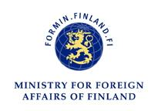

Application form for the
FOREIGN CORRESPONDENTS’ PROGRAMME 2013 IN FINLAND

Personal information
Family Name(s)
Given Name(s)
Date of Birth Place of Birth
Sex (M/F) Citizenship

Contact information
Street address
Postal code
City State/Province
Country
Email Mobile phone

Why do you wish to apply for the Foreign Correspondents’ Programme in Finland?

What do you wish to gain by attending the programme?

How do you think you will adapt to a group of multinational members?

Have you previously visited Finland? If yes - when?
How did you learn about the Foreign Correspondents’ Programme?

If you have any references, you may list them below

Name, Title, Address, Telephone

Name, Title, Address, Telephone

Additional information

I verify that I am the person identified on this form and that all of the above information about me is correct. Please check box.

Fill in the application; send it by email along with your CV, essay and photograph to the Embassy or Consulate General of Finland in your country of residence.

For more information, please visit:
http://formin.finland.fi → services → for media → Foreign Correspondents’ Programme.

The closing date for applications is March 22nd, 2013.

