[Form 2-2]

Pasting Sheet for Pay statements

Student No.: Student Name:

① Name on this statement （ ） ② Relationship（ ）
③ Company name （ ） ・If you are employed at multiple places, attach them to this sheet by each work place.
④ Employment date （ day month year）
⑤ A bonus Yes （ yen/year A ） ・ No
(If Yes, write the annual amount and submit copies of the documents that show the bonus amount)
⑥ Estimated annual income Calculate based on salaries of the last three months and fill in the following.
D Total of the last 3 months
（except transportation fee）
３
(months)
E Estimated annual income
A Bonus
（if any）

12

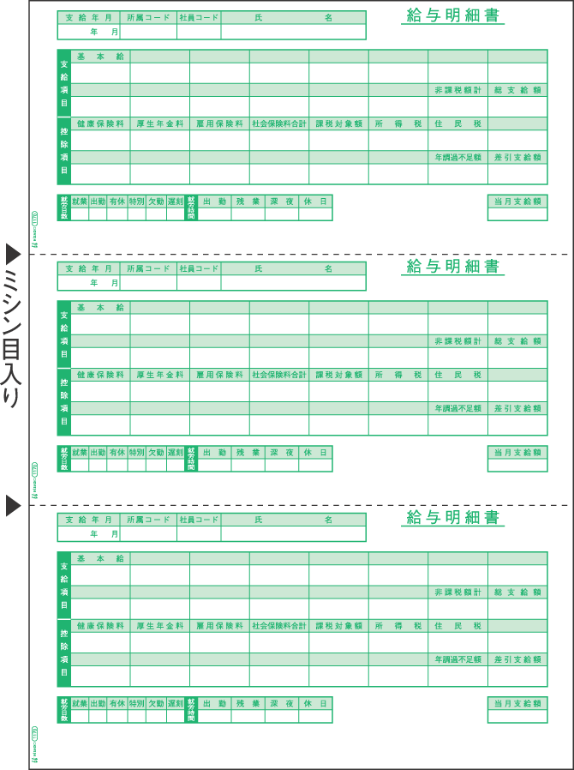
One-month income=
B (total amount)* – C (transportation fee)
(month) yen
(month) yen
(month) yen
D [total of 3 months] yen
【Notes】
・Please submit 〔Form 2〕 instead if you cannot submit pay statements of the last three months because of unstable jobs or because you were recently employed, lost pay statements, or when the actual income will be different from the above calculation.

・Enter the amount which you calculated above in your application.

* This is not‘net payment amount’.
⑦ Paste pay statements(給与明細書) of the last three months here

給与明細書
・If the copy is A4 size or larger, staple them to this sheet.
Pasting Sheet
for Pay statements
〔Form 2－2〕
Staple them together
・Please paste them on this sheet if copies are smaller than A4 size.
Transportation fee
Total amount
Net payment amount
Example

通勤手当
C
B

