Form 3

Final Tax Return Cover Sheet

Student ID No. (Examinee number) : Student’s Name:

Name of the earner: Relationship to the applicant:
Note: If there are multiple earners, please submit a separate Form 3 for each.
How to complete Form 3:
Please enter the amount of earnings (based on the final tax return) in the table below and submit this form together with a copy of final tax return. If you have salary income, please use Form 1 instead of this form.
Please enter the amount of regular income in the “Miscellaneous income” section. Do not enter temporary income.
It is not necessary to enter temporary income from stock transfers, retirement allowance, etc.

Type of Income | Amount of Income
Business income (sales, agriculture, etc.) | yen
Real estate income | yen
Interest income | yen
Dividend income | yen
Miscellaneous income | yen
Total: | yen

How to complete the “Income Information” section of the Application Form
- “Type of Income” field: Please enter “Final tax return” as the type of income.
- “Annual Income” field: Please round down the total amount above to the nearest thousand yen, and enter that
amount.
Other matters:
- If there are siblings indicated in the “Dependents” field of the final tax return who are no longer dependents as of the date of application, please enter their names and the reasons for the change of status.

- Name:

- Reason:
(Example: “gained employment,” etc.)
- Please submit copies of the pages of the Final Tax Return that include Sections 1 and 2 with reception stamps affixed. If there are no reception stamps on the pages, please explain the reason below. We may contact you about this at a later date. If you used the E-TAX system, please print and submit the webpages that show the date and time of transmission.

- Reason:
Sample
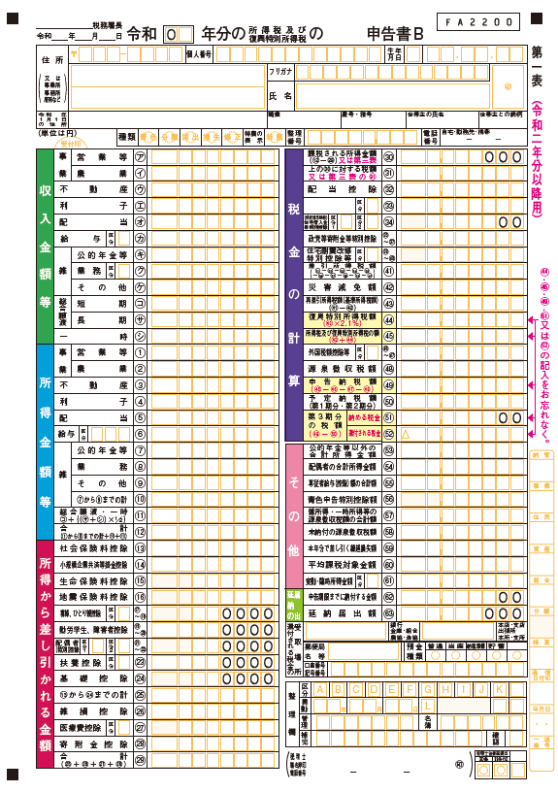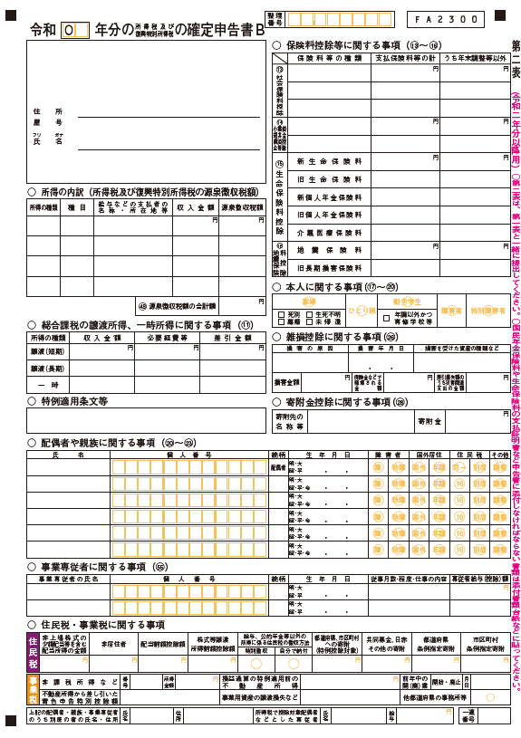
① “Dependents” field
② “Income breakdown” field

- Please make A4 size copies of the Final Tax Return, attach this cover sheet to the copies, and staple them together in the same orientation.

Staple the documents in the upper left corner.

Final Tax Return
Form 3
Final Tax Return Cover Sheet

