Form 2
Salary Statement Cover Sheet

Student ID No. (Examinee number) : Student’s Name:

Name of the earner: Relationship to the applicant:
Note: If there are multiple earners, please submit a separate Form 2 for each.
How to complete Form 2:
Please enter the appropriate figures in the spaces below and calculate the amount of “G. Annual Income” based on the salary statements for the most recent three months. Please submit copies of the salary statements together with this form. In the case of persons who are retired, it is not necessary to enter income earned prior to retirement.
Note: If there are multiple employers, please submit a separate Form 2 for each.

A. Name of Employer:

B. Month and Year of Employment: ,

C. Total Amount: ( yen (month: ) + yen (month: ) + yen (month: )) = yen

D. Commuting Allowance: ( yen (month: ) + yen (month: ) + yen (month: )) = yen

E. Average Monthly Income: ( yen (C. Total Amount) - yen (D. Commuting Allowance)) ÷ 3 months = yen *Rounded down to the nearest yen.

F. Bonus: yen
*Please list the total amount paid during the year.
If a bonus has already been paid, please attach a copy of a document verifying the amount.
If there is no bonus, enter 0 yen.
G. Annual Income: yen（E. Average Monthly Income）× 12 + yen (F. Bonus) = yen

How to complete the “Income Information” section of the Application Form
- “Type of Income” field: Please enter “Salary” as the type of income.
- “Annual Income” field: Please round down the total amount calculated in “G. Annual Income” above to the
nearest thousand yen and enter that amount.
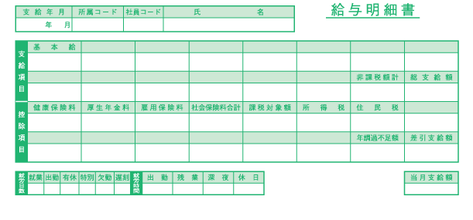
Sample:

通勤手当

D
C
- Please make A4 size copies of the salary statements, attach this cover sheet to the copies, and staple them together in the same orientation.
Salary statements
Staple the documents in the upper left corner.

Form 2
Salary Statement Cover Sheet

